
QUALITY ALERT

Customer: Amerilux Date: Jan 29, 2026
Die: 15191-15192 Colour: Any
Type of Complaint: QUALITY REQUIREMENT

Q.A # 25-062, 26-007 NCR: 027 RMA#: N/A

Description: Panel surface not flat, resulting in improper snap engagement and visible gap. Repeating issue
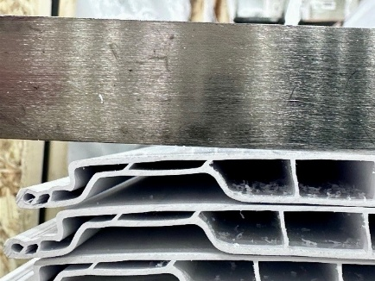
ENGAGEMENT TEST MUST BE PERFORMED USING 48” (3-4 FT) PANELS FOR ACCURATE RESULTS.

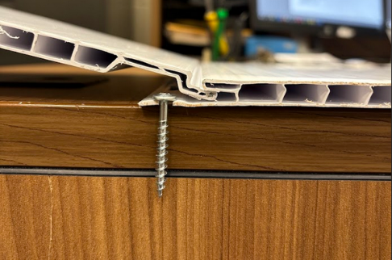
STEP 1: Hold one panel at a 30° angle, aligning the male edge with the female groove of the other panel.

Uneven panel surface

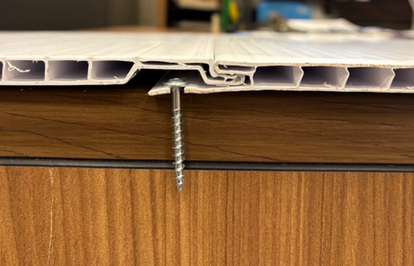
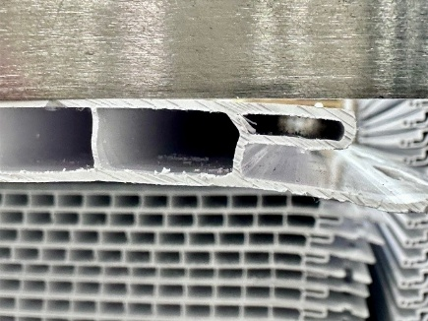
STEP 2: Push firmly to engage both panels until they are fully locked together. Snap must be easy and fully engaged with no visible gap.

Uneven panel surface
INSPECT PANEL SURFACE FLATNESS CAREFULLY; VERIFY 48” PANEL SNAP IS EASY, FULLY ENGAGED AND FREE OF VISIBLE GAP.

BY SIGNING BELOW, YOU ACKNOWLEDGE THE PROBLEM ABOVE AND AGREE TO MONITOR THIS ISSUE IN FUTURE PRODUCTION RUNS.
DAY SHIFT |  | AFTERNOON SHIFT |  | NIGHT SHIFT
NAME | SIGNATURE | NAME | SIGNATURE | NAME | SIGNATURE
F-006: Quality Alert | Eff.Date: 05/03/2025 | CC# 25-046 | Rev.0

